3D Point Cloud Completion Project Proposal

Setting: Although previous studies (PCN, PoinTr, SnowflakeNet) have attempted to address point cloud completion, from their perspective this process largely relies on shape priors in the training data (ShapeNet). These models are only successful in completing object categories they have previously encountered. However, generalizing these models to arbitrary, unseen objects in real world scenarios remains a significant challenge, as they often fail when they encounter out of distribution geometries. To address this, recent works have shifted towards leveraging large scale generative priors or category agnostic frameworks to achieve zero-shot point cloud completion. Here are the related works:

ComPC (ICLR 2025, NUS)

Link: https://arxiv.org/pdf/2307.14726
Code: https://github.com/Tianxinhuang/ComPC

Focus: completion via 2D image priors, 2D diffusion model
Process:
- partial Gaussian initialization
3D Gaussian Splatting
- zero-shot fractal completion
2D diffusion model
Rendering: looks at 3D object from different angles and create 2D images
Inpainting: asks model “This X, is missing x. Can you complete it?”.(generic prompts)
SDS(score distillation sampling): 2D model provides gradient to update 3D Gaussians,
pushes 3D blobs to move
until the 2D images rendered from every angle look like a complete object
- point cloud extraction

Summary: initializes a partial point cloud as 3D Gaussians, uses the generative power of 2D diffusion models to "paint in" missing regions from multiple rendered views, and finally extracts a complete, uniform 3D point cloud

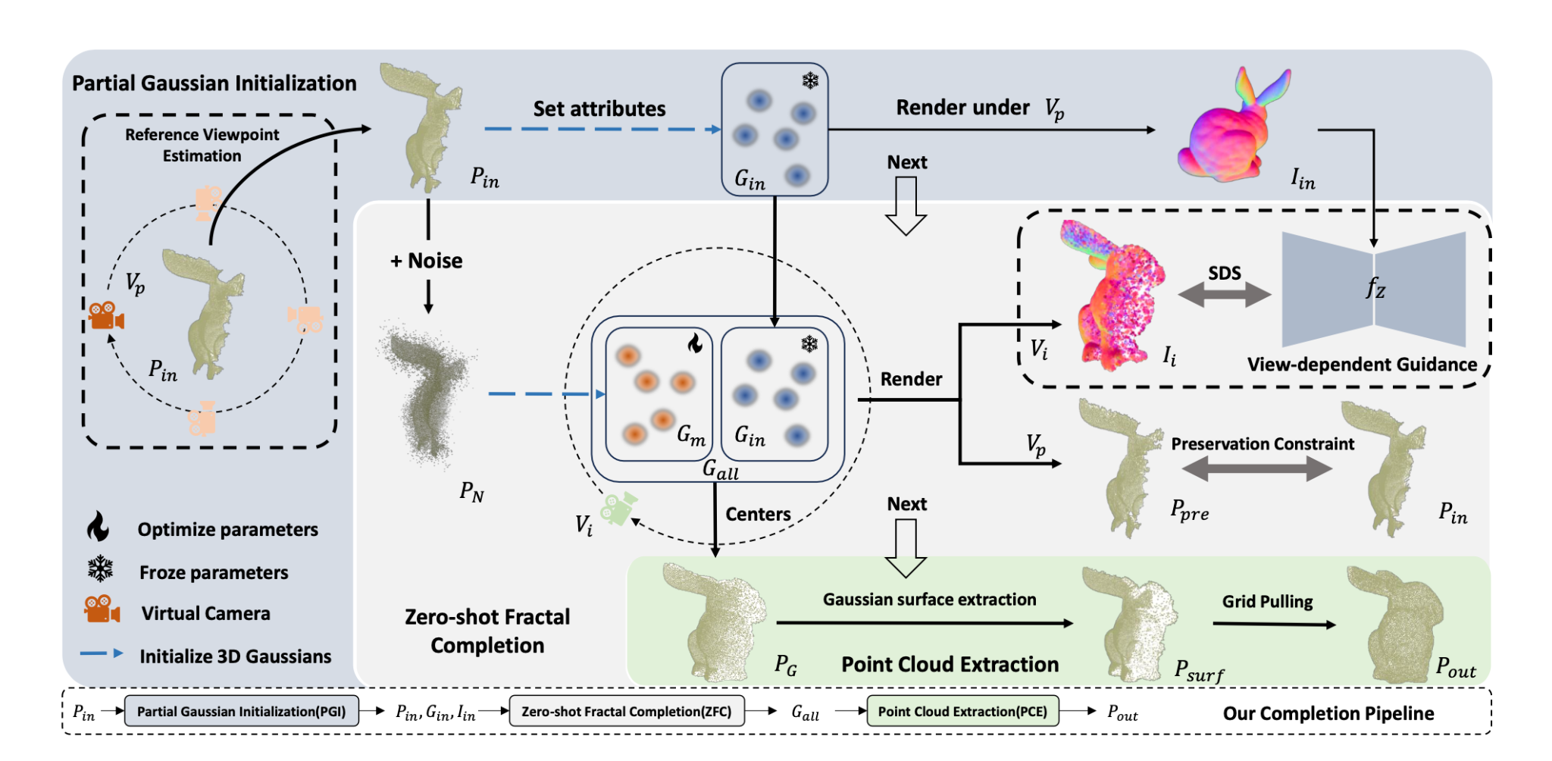

GenPC(CVPR 2025, Nanjing)

Link: https://arxiv.org/pdf/2502.19896
Code: not provided.
Focus: utilizing 3D generative model, depth prompting

Process:
- depth prompting = convert point cloud into depth map
- 3D generative priors
feed-forward estimation
- geometric preserving fusion

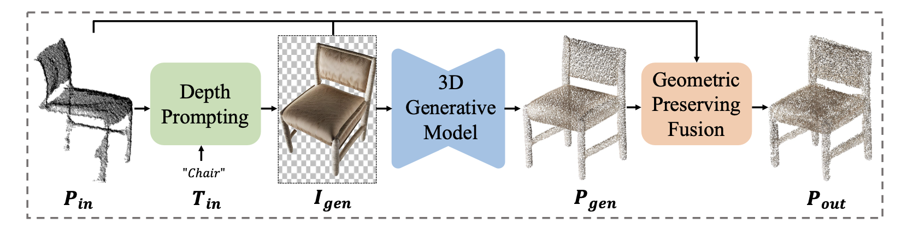

ComPose(CVPR May 2026 Oral, USTC, Best Paper Award Candidate)
Link: https://arxiv.org/pdf/2605.25553
Code: https://github.com/RenHuan1999/ComPose (repo is empty)
Focus: considering completion and pose estimation as a unified framework (although the paper reflects as their first objective is pose estimation, they are in a leveraging cycle)
Note: The model codes the handle of a cup not as a "part of the cup," but as "a geometric structure that bends at a specific curve and connects to the main body at two points." Thus, this model is also not directly zero-shot, however it is category agnostic.

- partial feature extraction(Pointnet++ -> initial representation, SecondPose -> pose-consistent semantic features, self-attention )
- keypoint based progressive completion
inspired by AdaPointr
coarse keypoint generation: (maxpooling -> MLP)C_miss + (FPS)C_vis concat, C_cand -> scoring MLP, C_kpt
progressive shape completion: Transformer decoder -> P_kpt and P_com
- tightly integrated feedback = as the completion module improves, the exposure estimation module sees a clearer geometry. As the exposure module becomes clearer, information such as "X is positioned at t angle, so you should complete its background in this way." is sent to the completion module.
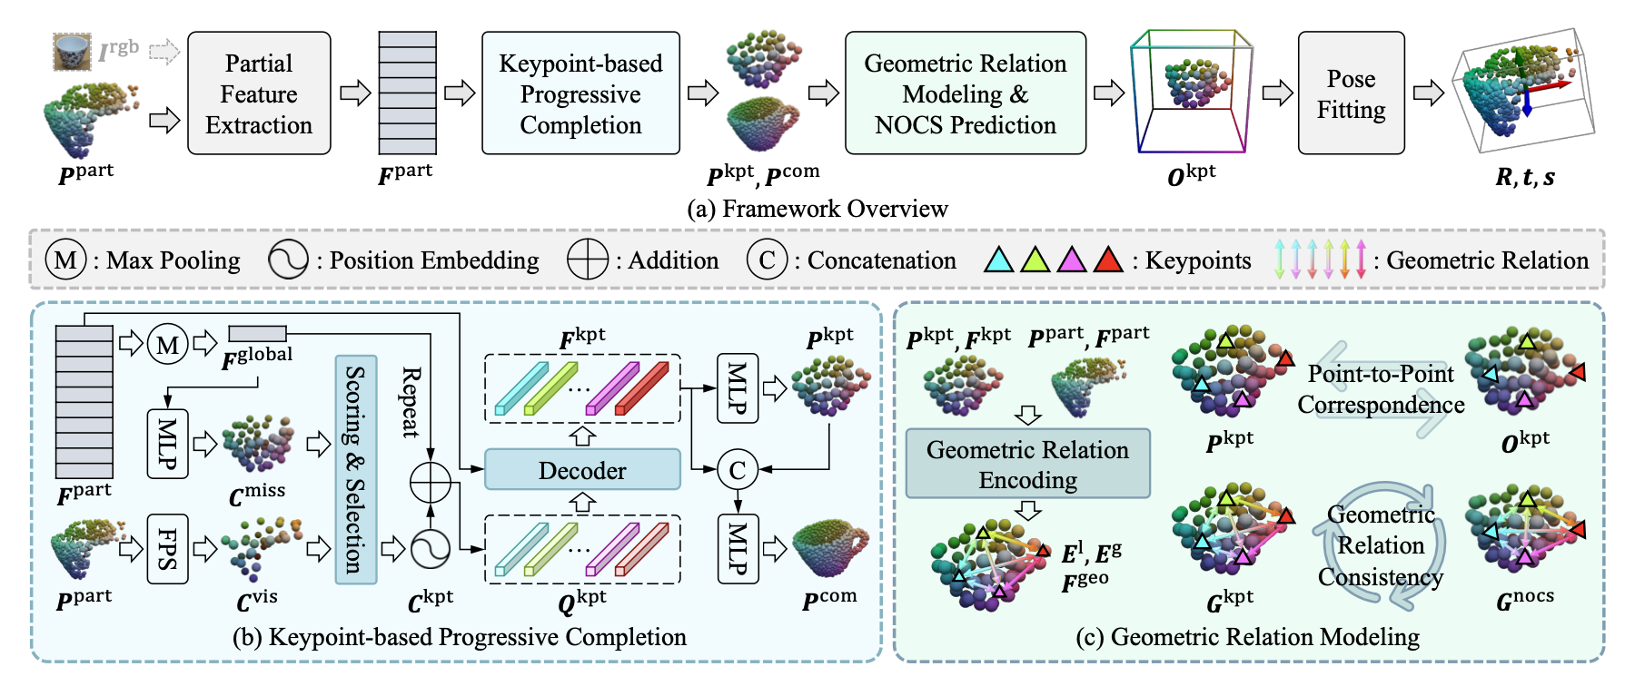

Proposal

Problem: Current 3D point cloud completion frameworks predominantly focus on recovering purely geometric structures, often ignoring the rich visual information (texture, color, and material) of the objects. While recent category agnostic models like ComPose have successfully unified geometry completion with downstream tasks like pose estimation, they still treat the object as an untextured point set. On the other hand, multimodal approaches like ComPC utilize 2D generative priors to guide 3D completion but often follow a decoupled pipeline, relying on 2D inpainting first and then back projecting to 3D.
This separation may lead the model to complete the shape, but the resulting geometry may lack the fine grained surface details or material consistency that only an integrated 2D-3D analysis can provide. There is a lack of a unified framework that treats geometry recovery and texture synthesis as mutually reinforcing processes, rather than sequential steps.
Research Question: Can we develop a unified, category agnostic framework that integrates the multimodal generative priors (as inspired by ComPC) with the progressive unification strategy (inspired by ComPose) to simultaneously recover both the missing geometry and the corresponding surface texture of 3D objects, and does this joint texture/geometry completion provide a more robust structural representation for downstream tasks compared to purely geometric approaches?

Note: PointDreamer as a sequential approach https://arxiv.org/pdf/2406.15811
(not published)

Proposed Method: Instead of converting point clouds to meshes or relying on a sequential pipeline (as seen in PointDreamer), I propose to treat geometric coordinates (x,y,z) and pointwise color features (r,g,b) as a unified multimodal signal.
The core idea is to investigate whether texture completion and shape completion can be treated as a single, codependent process within the point cloud domain.
slack group
GPU
AWS GOogle

